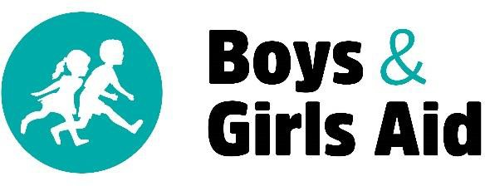

Dear Friend,

It is with great excitement that we invite you to participate in a very special event! The 2020 Crab & Rib Dinner, benefiting Boys & Girls Aid, is scheduled for Saturday, March 14, 2020 to be held at the Charbonneau Country Club. We are seeking donations for the silent auction and your support will make a difference!

On any given night in Oregon, there are 8,000 children living in foster care without a home. Boys & Girls Aid is committed to serving these children by connecting them with stable families who will offer them a lifetime of guidance, support, and love. Boys & Girls Aid works with children in foster care to understand their past, ensure their safety, and connect them with a permanent family.

The Crab & Rib Dinner is a delightful event organized by the Cypress Branch Auxiliary, a volunteer auxiliary of Boys & Girls Aid. This sell-out event features a buffet of crab and ribs, a beautiful silent auction, and a fun evening for all.
Last year, more than 200 guests attended and raised more than $70,000 for Boys & Girls Aid and the children they serve.

We invite you to partner with us at the 2020 Crab & Rib Dinner by donating an item to our auction. We are confident that your in-kind contribution will allow us to increase the funds raised for the children who need it most – we hope you will join us!

If you have any questions about the Crab & Rib Dinner or Boys & Girls Aid, please contact Megan Bos at 503.542.2345.

Thank you for your support! Sincerely,

Cypress Branch Auxiliary Member

Boys & Girls Aid Tax Identification Number: 93-0386791

